PID CONTROLLER FOR CRUISE CONTROL OF THE CAR

MASS OF THE CAR: 1000 kg
DRAG COEFFICIENT: 50 Ns/m
SET VALUE: 20 m/s

The Values I used for Kp, Ki and Kd are:
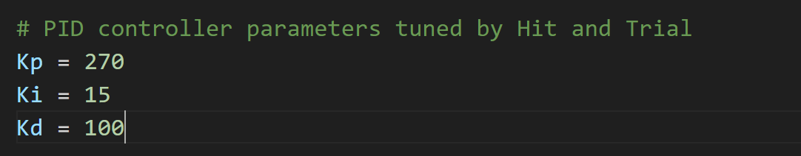

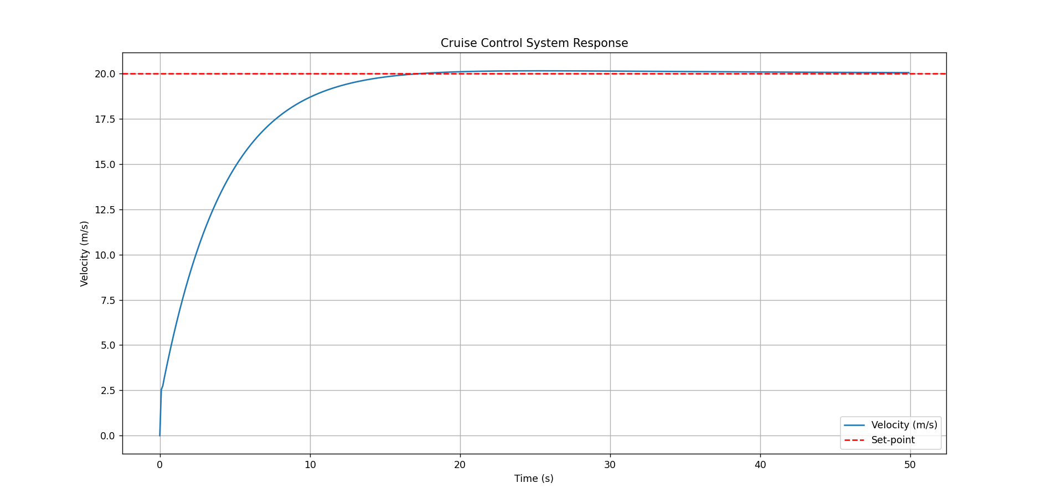
The graph plotted:

